Part A
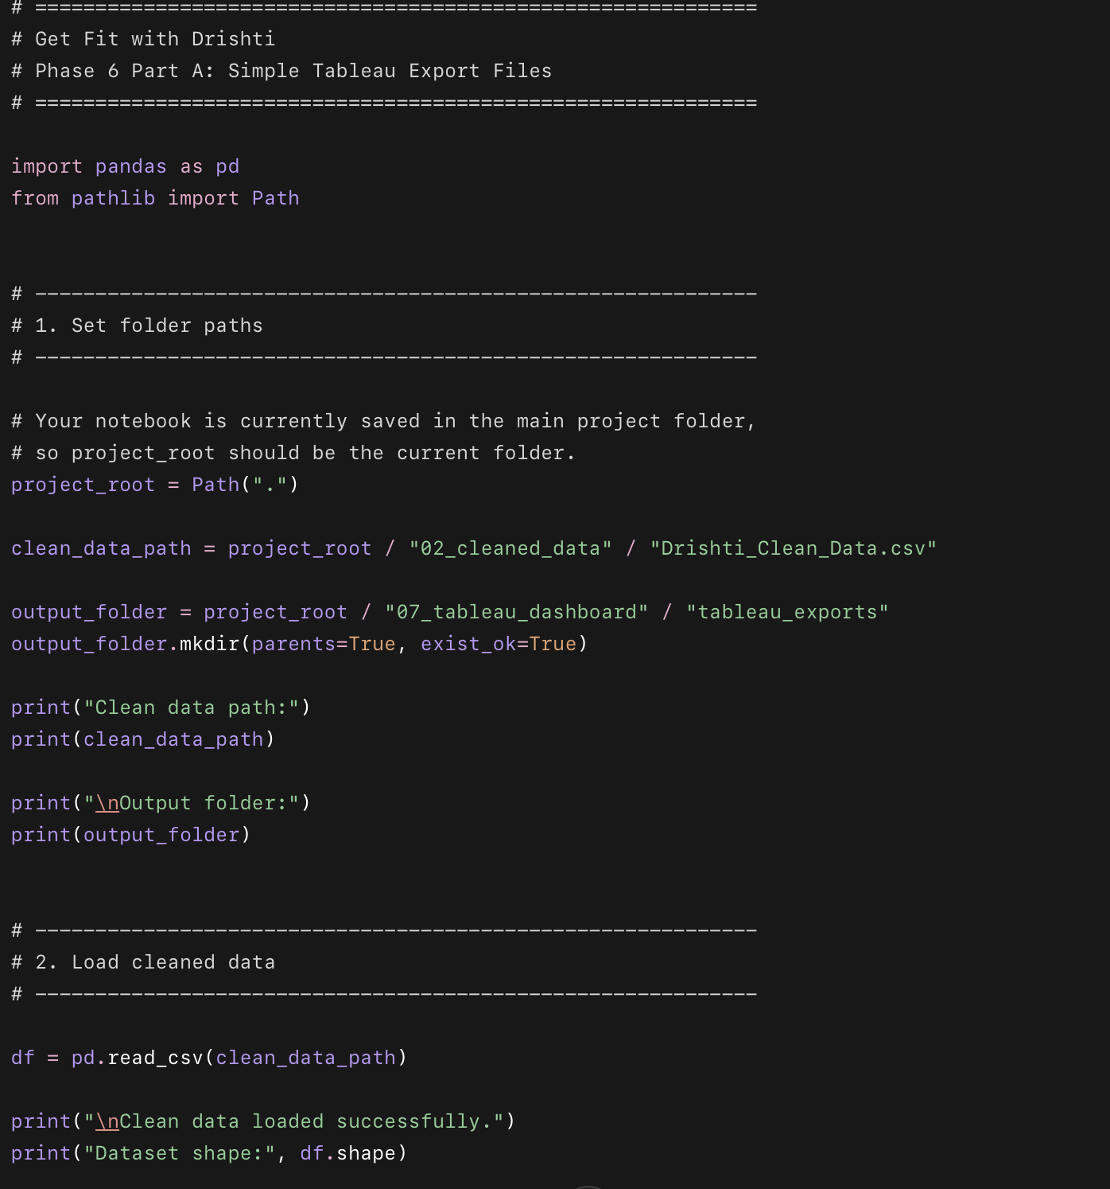
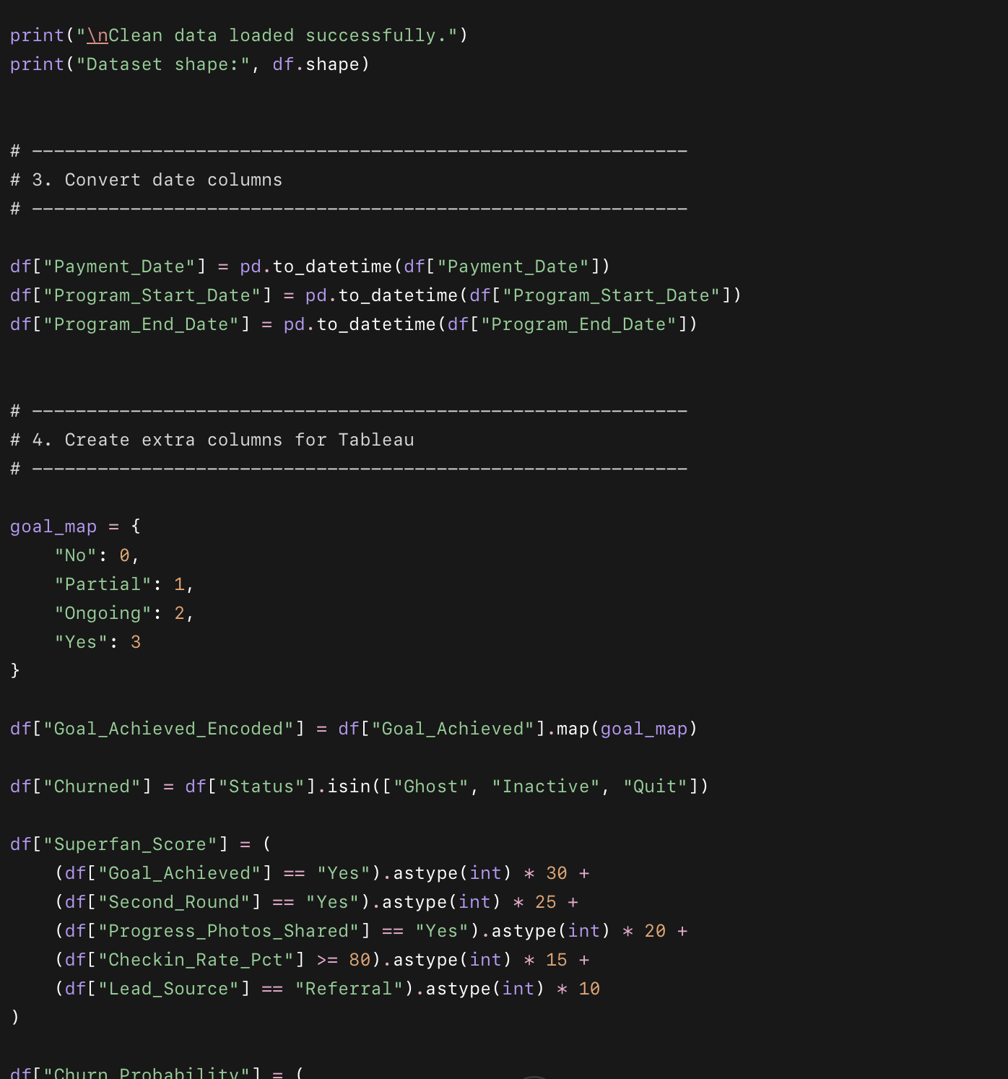
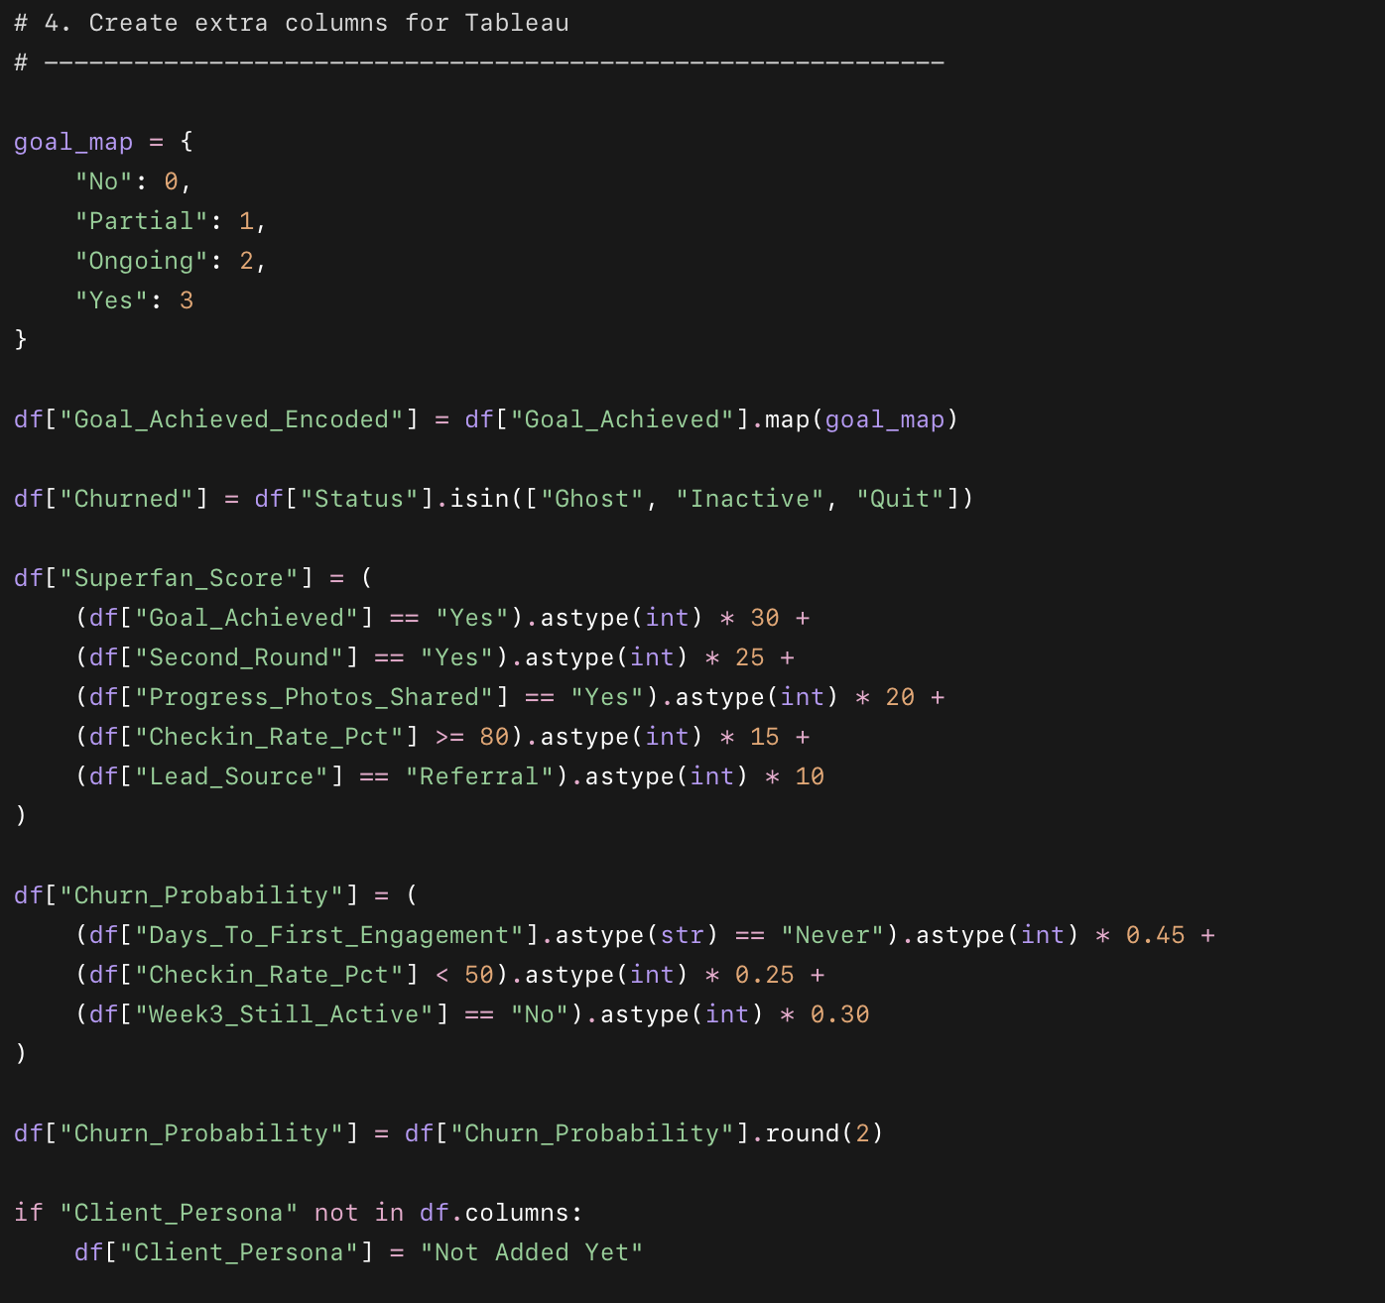
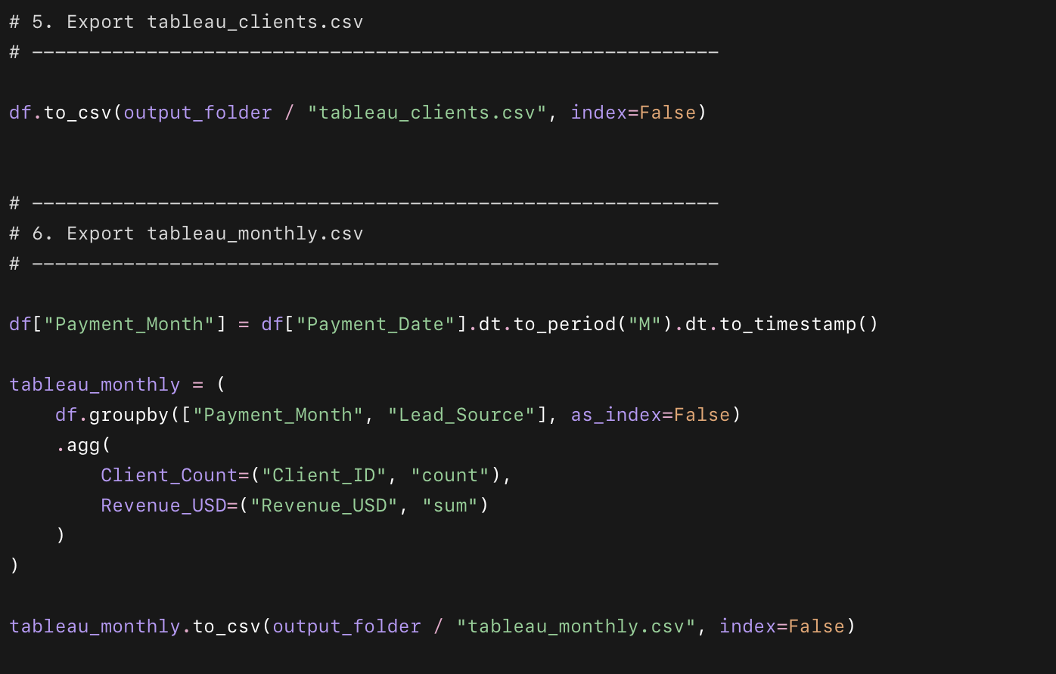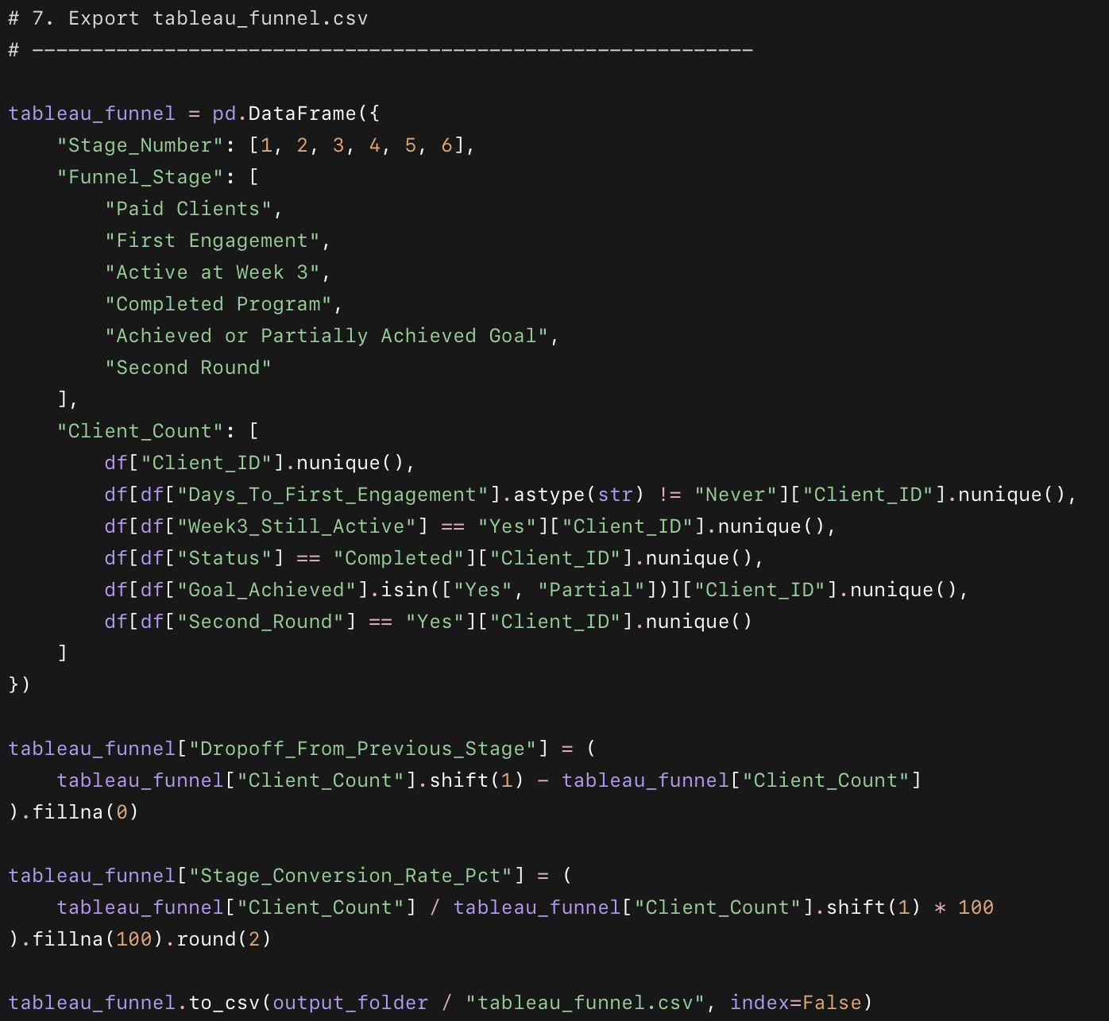
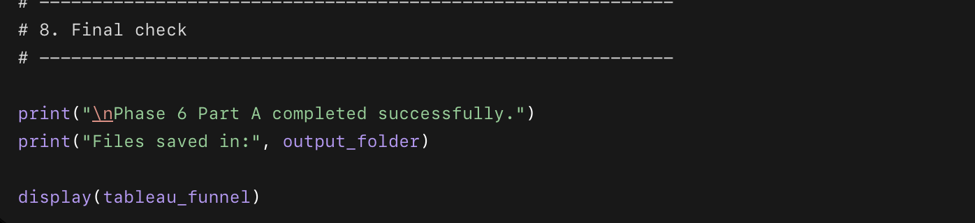

What the code does
- Finds the main project folder.
- Finds the cleaned dataset from 02_cleaned_data.
- Creates a new folder for Tableau exports.
- Loads the cleaned client data into Python.
- Converts date columns into proper date format.
- Creates a number version of Goal_Achieved for Tableau charts.
- Creates a Churned column to identify dropped clients.
- Creates a simple Superfan_Score.
- Creates a simple Churn_Probability score.
- Creates a monthly summary by Lead_Source.
- Creates a 6-step client funnel.
- Saves 3 final files for Tableau:
  - tableau_clients.csv
  - tableau_monthly.csv
  - tableau_funnel.csv

Why we used this code
- To prepare clean files for Tableau.
- To avoid doing too many calculations manually inside Tableau.
- To make the dashboard easier to build.
- To make the dashboard easier to update later.
- To show business insights clearly:
  - growth
  - retention
  - churn risk
  - Superfan clients
  - referral potential
  - funnel drop-off

TABLEAU DASH BOARD

What we did
- Built the first KPI tile: Total Clients.
- Used a distinct count so each client is counted once.
- Removed extra worksheet clutter.
- Centered and formatted the KPI like a business dashboard metric.

Why it is important
- This KPI shows the total client base: 3,000 clients.
- It gives business context before looking at completion, churn, referral, or Superfan metrics.
- It makes the dashboard feel executive-ready instead of looking like raw analysis.

- Created the Completion Rate % calculation.
- Counted clients whose status is Completed.
- Divided completed clients by total clients.
- Built a KPI tile showing the business completion rate.

Why it is important
- This tells Drishti how many clients actually finish the program.
- It directly measures retention and client follow-through.
- A high completion rate means the coaching system is working.
- If this number drops in future months, Drishti knows retention needs attention.
3.

What we did
- Created the Goal Achievement Rate % calculation.
- Counted clients whose Goal Achieved value is Yes.
- Divided that by total clients.
- Built it as a clean KPI tile.

Why it is important
- This shows how many clients fully reached their goal.
- It measures the actual client outcome, not just program completion.
- It helps Drishti understand if clients are getting the result they came for.
4.

What we did
- Created the Superfan % calculation.
- Counted clients with Superfan Score of 70 or higher.
- Divided that by total clients.
- Built a clean KPI tile for word-of-mouth potential.

Why it is important
- This shows how many clients are strong advocates.
- These clients are likely candidates for testimonials, referrals, and transformation stories.
- It helps Drishti build a repeatable word-of-mouth system instead of waiting for random referrals.

5. What we did
- Created the Second Round Rate % calculation.
- Counted clients who signed up again.
- Divided that by total clients.
- Built a clean KPI tile for repeat client behavior.

Why it is important
- This shows how many clients trusted the program enough to continue.
- It measures repeat business and client loyalty.
- It helps Drishti understand how strong her long-term client relationship is.
6. dashboard

What we did
- Created the top Business Pulse row.
- Added all 5 KPI tiles side by side.
- Made the dashboard start with the most important business numbers.

Why this is important
- Drishti can quickly see overall business health.
- The row summarizes clients, completion, goal success, superfans, and repeat signups.
- It makes the dashboard feel like a real business tool.
Health acquisition line chart 1

What we did
- Created a monthly line chart.
- Put Payment Date by month on the x-axis.
- Counted unique clients on the y-axis.
- Used Lead Source as color.
- Compared TikTok, Referral, Instagram, and Other over time.

Why it is important
- This shows where new clients are coming from each month.
- It helps Drishti see if TikTok is still growing or starting to flatten.
- It also shows whether referrals are becoming stronger over time.
- This is important for deciding where to focus content and marketing effort.
TikTok and referrals are the main growth engines.
Other sources are small and inconsistent.

Scatter plot: View 3 - Engagement Success Link

What we did
- Created a scatter plot.
- Put Checkin Rate Pct on the x-axis.
- Put Goal Achieved Encoded on the y-axis.
- Added Client ID so each dot represents one client.
- Colored clients by persona or status.

Why it is important
- This chart shows the connection between engagement and results.
- It helps prove whether check-ins are linked to goal achievement.
- It gives Drishti a visual way to understand which clients are succeeding and which clients need support.
- This is the central business insight of the dashboard.

